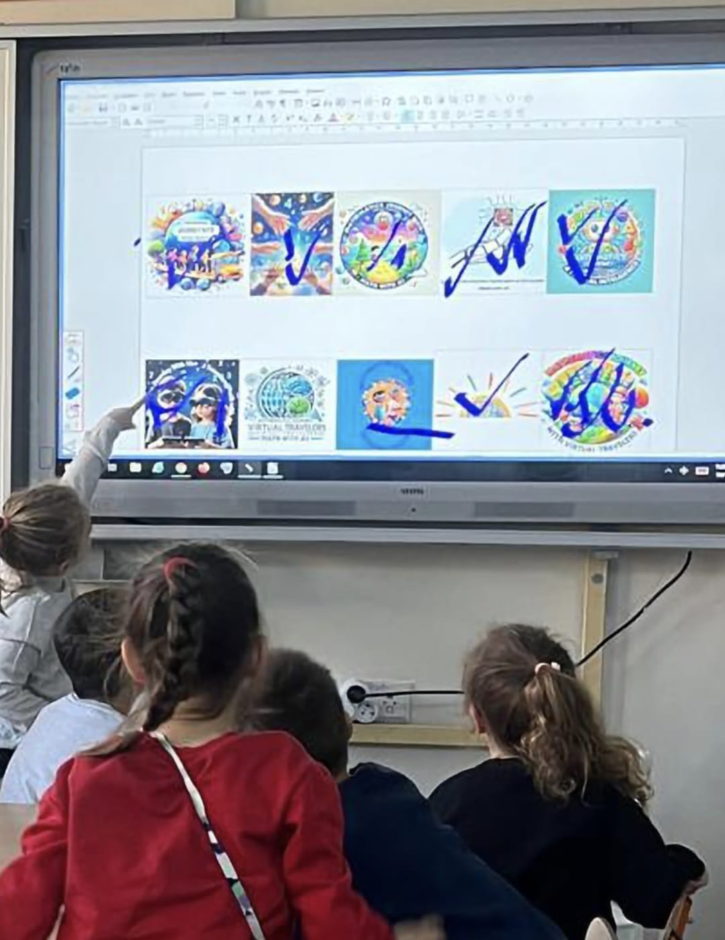

**OUR ETWINNING PROJECT IS STARTING**

**MATHEMATICS JOURNEY WITH VIRTUAL TRAVELLERS**

**(WITH ARTIFICIAL INTELLIGENCE APPLICATIONS)**

In the 21st century, we will use the applications of artificial intelligence technology in our project. In the researches examined, it has been observed that the use of artificial intelligence in mathematics education is effective in improving students' mathematical thinking and problem solving skills, learning experiences and evaluation processes. Mathematics education is fundamental in terms of contributing to children's cognitive development, fostering a positive attitude towards mathematics in children, helping children to make connections between their previous conceptual knowledge and new knowledge, and helping to understand why and how mathematical concepts are used. Mathematics activities develop mathematical questioning skills in children. With the applied mathematics activities, children can recognise patterns in their environment, develop assumptions and test them, solve problems, reason and communicate using mathematical concepts. In this sense, the use of artificial intelligence applications should be included in mathematics teaching. Using artificial intelligence applications in mathematics teaching will be useful in terms of encouraging creative and innovative thinking. Thus, permanent learning will be provided.

For these reasons, in this project, we aim to develop positive attitudes in students in mathematics teaching and increase the permanence of teaching by using artificial intelligence applications in mathematics teaching.

We have chosen our logo together with our students, we expect the support of all our parents.